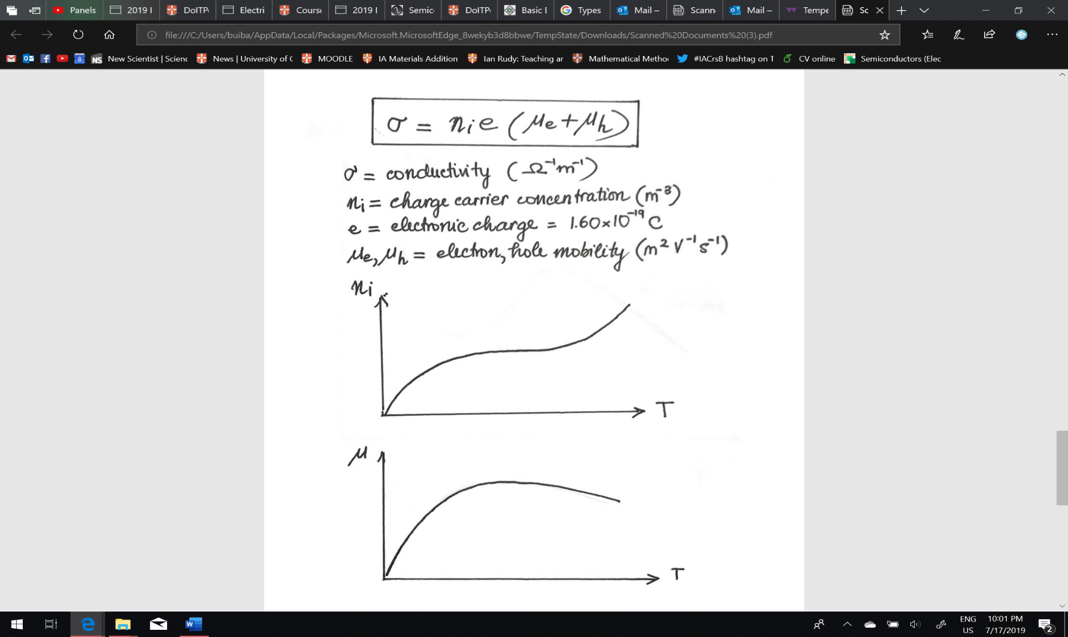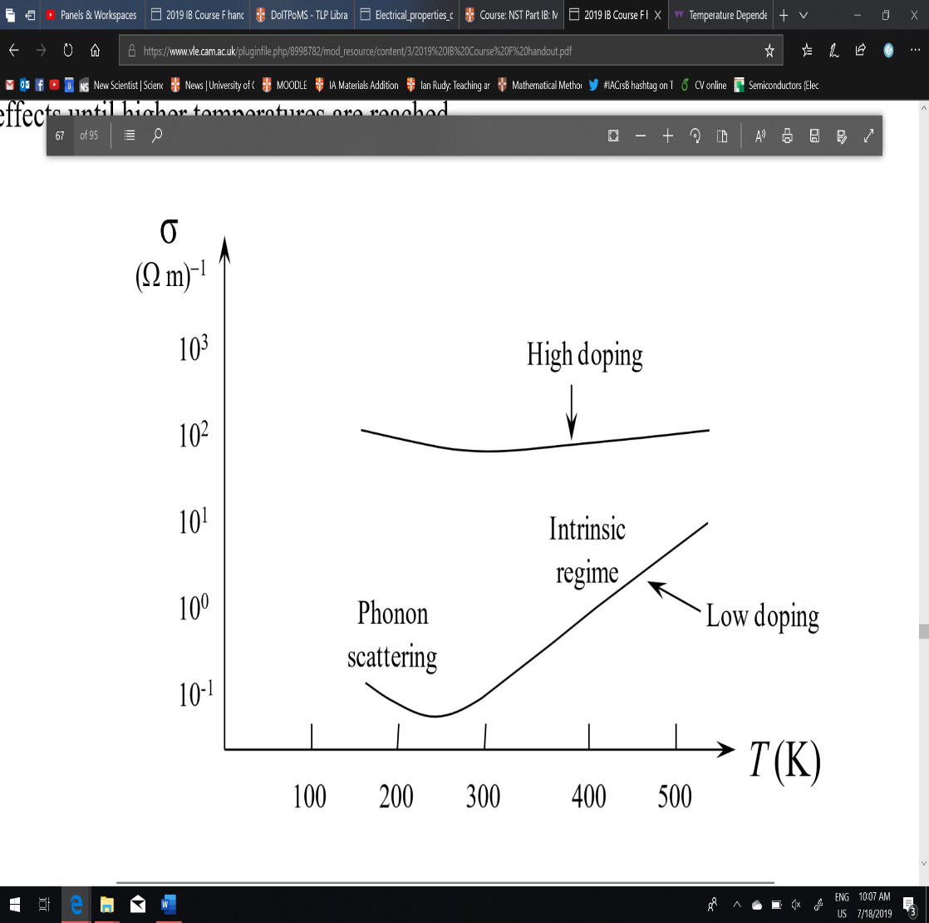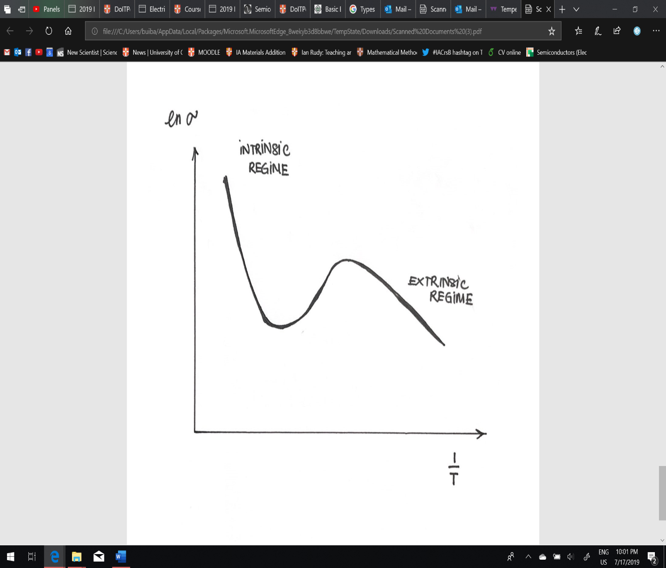

For low doping levels, the conductivity first decreases although carrier concentration increases because lattice vibrations dominates. As temperature increases more, electrons can cross the band gap so effect of increasing carriers outweights effect of decreasing mobility. For high doping levels, conductivity is higher overall because there are more charge carriers. This also means that the effect of temperature is less pronounced since the rate of increase in carrier concentration balances the decrease in mobility.

Conductivity doesn’t just depend on the charge carrier – it also depends on the carrier mobility, As temperature increases, the mobility of electrons and holes increases at first due to gain in kinetic energy. Then it decreases when lattice vibration takes over and impede their motion